|  |  |  |  |
| --- | --- | --- | --- |
| **Course Name:** | **Automation and Control System** | **Semester:** | **V** |
| **Date of Performance:** | **11-09-24** | **Batch No:** | **B-1** |
| **Faculty Name:** |  | **Roll No:** | **16014022050** |
| **Faculty Sign & Date:** |  | **Grade/Mark:** |  |

Experiment No:

Title: Implementation of up-down counter

|  |
| --- |
| **Aim and Objective of the Experiment:** |
| 1 . Study Counter timing diagram.  2. Develop an application specific ladder program using counters. |

|  |
| --- |
| **COs to be achieved:** |
| CO4: Interface PLC using proper communication device |

**Theory:**

**Develop an application using Up-Down Counter Introduction**

Counters are used to count number of objects or to count cycles of a typical process. Consider an example of bottle filling plant, in that counter is used to count number of bottles filled in a particular batch.

In counter instruction the accumulated value will increase only when it completes the transition from open to close or vice versa. It doesn’t check how long contact stay closed, it only looks for the transition. There are two basic types of counter

1. Up-Counter (CTU)
2. Down-Counter (CTD)

In Up counter when contact change over takes place accumulator value increments by one. While in counter when changeover takes place accumulator value decrements by one.

The instruction blocks of up counter and down counter are as shown below.

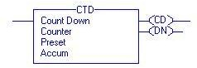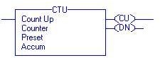

**Count Up (CU) Bit: -** The Count Up enable bit indicates the CTU instruction is enabled. The data type used is Boolean indicated as BOOL.

**Count Down (CD) Bit: -**The Count Up enable bit indicates the CTD instruction is enabled.

**Done (DN) Bit: -**The done bit changes state whenever the accumulated value reaches the preset value. The data type used is Boolean indicated as BOOL.

**Overflow (OV) Bit: -**The overflow bit indicates the counter exceeded the upper limit of 2, 147, 483, 647. The counter then roles over to -2, 147, 483, 648 and begins counting up again. The data type used is Boolean indicated as BOOL.

**Underflow (UN) Bit: -**The underflow bit indicates that the counter exceeded the lower limit of -2, 147, 483, 647. The counter then roles over to 2, 147, 483, 647 and begins counting down again. The data type used is Boolean indicated as BOOL.

**Preset (PRE) Bit: -**It specifies the value which the accumulated value must reach before the

instruction sets the done bit. The data type used is Double integer indicated as DINT.

**Accumulator (ACC) Bit: -**It specifies the number of transitions the instruction has counted. The timing diagram illustrates the functioning of all the bits in sequence.

|  |
| --- |
| **Circuit Diagram/ Block Diagram:** |
| Timing Diagram for Up Counter:-  http://plc-coep.vlabs.ac.in/images/Timing%20Diagram%20for%20Up%20Counter.jpg  Timing Diagram for Down Counter:-  http://plc-coep.vlabs.ac.in/images/Timing%20Down%20Counter.jpg |

|  |
| --- |
| **Stepwise-Procedure:** |
| **Develop an application using Up-Down Counter**  Implement the counter using Simulator   1. The counter counts the pulses received at input. The pulses can be given by toggling the input bit “ON” in this case. 2. The counter will keep on counting till it reaches the preset value set by the user. Once the accumulator is equal to preset the DN bit will be energised. 3. After this instant if next pulse is detected the accumulator will increment without changing the status of DN bit. 4. To reset the counter use “Reset” command so that the counter can be configured for new counts without reloading the Page.   Please note the tag of the reset bit must be the tag of counter e.g.“CTU”.  In case of down counter the entire procedure will remain same. Only the number of counts are to be entered in the accumulator tab. The preset value is zero. When the input contact closes, the accumulator will go on decrementing, will reach to zero '0' value and the status of done bit will change.  To reset the DN counter use “Reset” command so that the counter can be configured for new counts without reloading the page. Please note the tag of the reset bit must be the tag of counter. |

|  |  |  |
| --- | --- | --- |
| **Simulation:** | | |
| 1. **Down Counter:** 2. **Upcounter:** | | |
|  |  |  |

|  |  |  |
| --- | --- | --- |
|  |  |  |
| **3)Updown counter**  Initial stage: | | |

Down

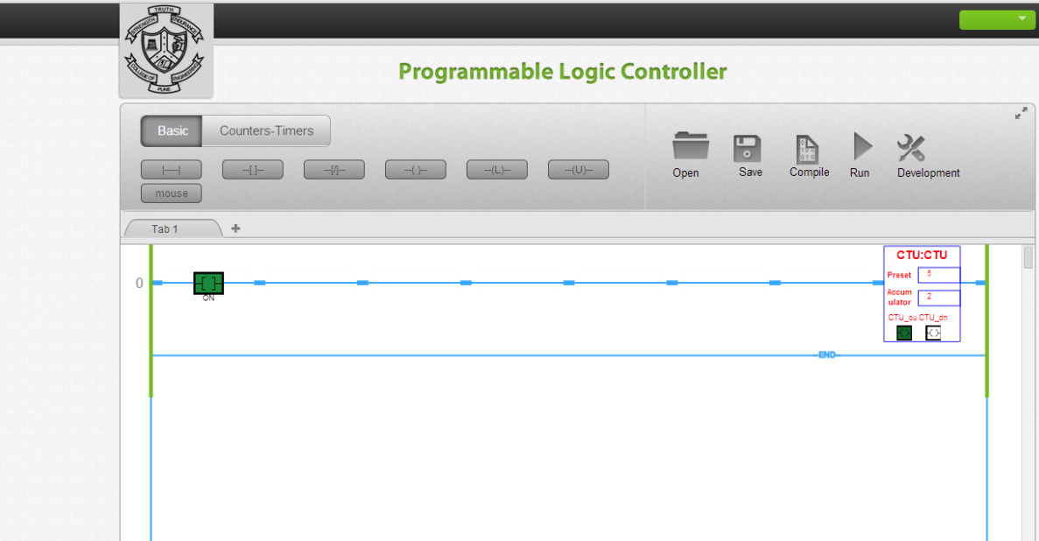

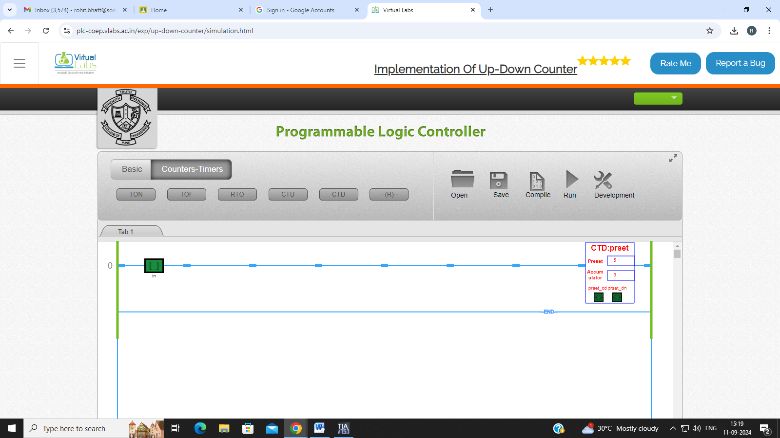

Up

|  |
| --- |
| **Post Lab Subjective/Objective type Questions:**  Develop an application using Up-Down Counter |
| **1. In up counter instruction the accumulated value will increase only when**   1. There is complete transition from low to high 2. There is complete transition from high to low 3. Can’t Say   **Answer:**   1. **In down counter instruction the accumulated value will decrease only when**    1. There is complete transition from low to high    2. There is complete transition from high to low    3. Can’t Say   **Answer:**   1. **The duration of input transition pulse is the deciding factor for counting the pulse in case of counters**    1. True    2. False    3. Not always false   **Answer:**   1. **The done bit of counter changes state when**    1. the accumulated value reaches the preset value    2. The overflow bit is set    3. The accumulated value reaches to overflow value   **Answer:** |

1. **In case of CTU the done bit status is when the accumulated and preset values are equal**
   1. Close
   2. Low
   3. High

**Answer:** c) High

**Conclusion:**

We studied function of Down counter, Up counter, UpDown counter. The Down counter takes a preset value which is loaded and accordingly the counter keeps decrementing, in Up counter there is reset which reset the states and keeps incrementing up till preset value.

In UpDown counter we first load the preset value and decrement it then if continue toggling it will automatically start incrementing and behave as an Up counter.

**Signature of faculty in-charge with Date:**